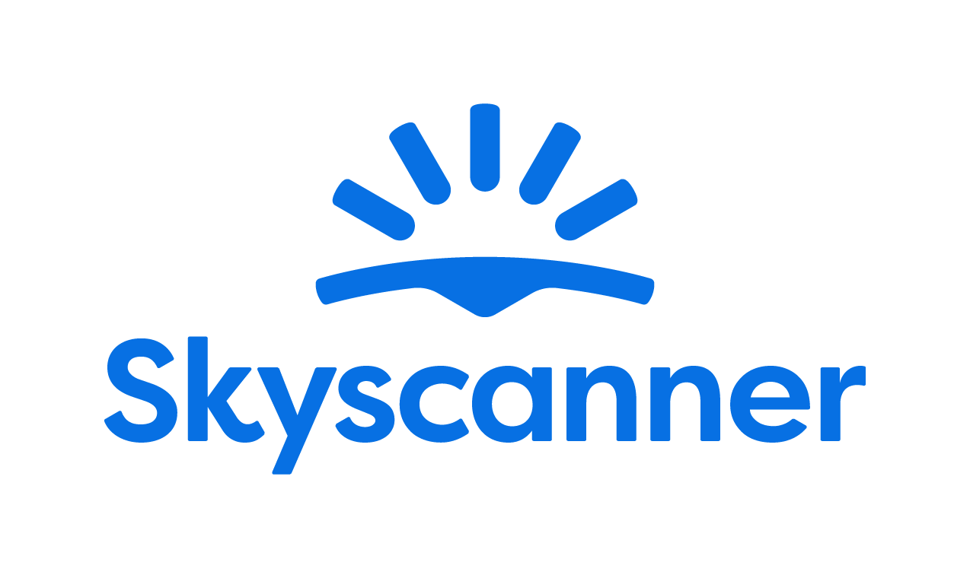

Localisation Style Guide

How to write and translate for Skyscanner in Danish

1. Our Tone of Voice 4
1.1 Playful 4
1.2 Geeky 5
1.3 Helpful 6
1.4 Using the tone of voice in localisation 8
2. General writing and translation guidelines 9
2.1 URL requirements 9
2.2 Placeholders, variables and tags 9
2.3 Inclusive language 10
3. Language-specific translation guidelines
11
3.1. Punctuation and spacing 11
3.1.1. Commas 11
3.1.2. Ellipsis 11
3.1.5. Hyphens 11
3.1.6. Dashes 11
3.1.7. Full stops 11
3.2. Emphasis and intensifiers 11
3.3. References 12
3.4. Capitalisation 12
3.4.1. Titles and CTAs 12
3.4.2. Months and days 12
3.4.3. Capital letter after colon 12
3.4.4. Glossary terms / product names 12
3.5. The use of Anglicisms 13
3.6. Abbreviations and acronyms 13
3.7. Addressing our users – Formality and T/V policy 14
3.8. CTAs and active voice 14
3.9. Linguistic sequence 14
3.9.1. Transliteration 14
3.9.2. Geo-terms 15
3.9.3. Airport names 15
4. Cultural sensitivity 15
4.1. Emojis and symbols 15
4.2. Imagery 16
5. Translation guidelines per content type 16
5.1. User Interface (UI) 16
5.2. Marketing 16
5.3. SEO 17
5.4. Google Ads 17
5.5. App store 17
5.6. Editorial and blog posts 18
5.7. Emails and push notifications 18
5.8. Legal, Policies, Terms and Conditions 18
6. Other Skyscanner-specific guidelines 19
6.1. Use of Skyscanner brand 19
6.2. Feature naming 19
6.3. The use of “Best” 20
6.4. The use of “Discount” 20
6.5. Translating sustainability-related content 21
6.6. Accessibility guidelines 22
7. Useful resources and links 22

Our Tone of Voice

Skyscanner sounds like a Geeky Travel Pal. This means that:
- Our tone is playful
- Our energy is geeky
- Our message is helpful
Our brand promise is to be a helpful, honest travel ally. Our tone of voice should always support this:
- We give clear, useful information so travellers feel savvy.
- We are fair and transparent, so travellers feel confident and secure.
- We lead with empathy, so travellers feel valued and understood.
When localising, keep the same personality, but adapt expressions so they feel natural in your language and culture.

1.1 Playful
Our tone is playful. We write with a light, natural energy. Playfulness helps us feel human and builds trust – but it must never reduce clarity.
What playful means for us:
- A conversational tone, as if talking to a friend.
- A rhythm that feels lively, not flat or robotic.
- Turning travel frustrations into simple tips and “travel hacks”.
Example:
Instead of: Compare multiple airlines simultaneously and eliminate the need for multiple browser tabs.
We’d say:
Do | Don’t
Endelig er der en måde at sammenligne flyrejser p uden at skulle åbne så mange faner, at computeren bliver træt. | Advarsel: Vores værktøj til sammenligning af fly finder tilbud så hurtigt, at du tror, din browser har speederen i bund! Spænd selen og få rabatterne!

Use these tools when they feel natural and keep meaning clear (and when they work in Danish):
- Rimes – e.g., “Lav pris, mere fis.”
- Alliteration – e.g., “Fede ferier”
- Metaphores – e.g., “Lave priser kan være som ræve. Der det ene øjeblik, væk det næste.”
- More interesting adjectives – e.g., “Skinnende” instead of “Lysende”
Use these tools sparingly and only if they localise well:
- Puns (Nothing too obvious or too corny).
- Long compound adjectives – e.g., “kan-det virkelig-være-sandt-visninger”.
- Elongated vowels – e.g., “Smuukt”.
- Interjections – e.g., “Åh, Ah. Puha.”
Always choose clarity over wordplay. If a device is hard to adapt or sounds unnatural in your language, do not use it.
Avoid
- “Fake-smart” corporate or management speak.
- Overly formal or stiff phrases.
- Trying too hard to be “LOL-funny”.

1.2 Geeky
Our energy is geeky: we love data, details and patterns—and we explain them in a human way.
What geeky means for us:
- We sound excited to share what we’ve learned.
- We show our travel expertise and curiosity.
- We break down complex information into simple steps.
Keep the tone enthusiastic but controlled. It should feel like a knowledgeable friend, not a lecture.
Instead of: We have the low-down on maximum baggage weight allowances across most major airlines so you can avoid fees and stress.
We’d say:
Do | Don’t
Vi kender vægtgrænserne for 137 flyselskaber, så du undgår gebyrer og stress. | Vil du nørde forskellige vægtgrænser? Vi følger HVERT. ENKELT. GRAM. på tværs af 137 flyselskaber!!!

1.3 Helpful

Helpful is our foundation. If you must choose between playful, geeky and helpful, be helpful first.
Our writing should:
- Make complex travel information simple.
- Make confusing situations clear.
- Make overwhelming choices manageable.
Instead of: Skyscanner has real-time data on the cheapest flights, based on the day of the week.
We’d say:
Do | Don’t
Vil du vide, hvilken dag det er billigst at flyve? Vi finder det til dig. | Hvis du prøver at finde ud af, hvilken dag det er billigst at flyve, men det er alt for overvældende, alt for mange hjemmesider, alt for mange faner! Træk vejret. Det er det, vi er her for.

How to write helpfully
1. Put travellers first
- Focus on what they need to know, not on us.
- Start with the benefit or instruction, then explain how we know.
- Ask nicely—to help the traveller take action, they’ll be more inclined if we’re polite and respect their time.
Do | Don’t
Vil du vide, hvilken dag det er billigst at flyve? Vi finder den til dig. | Hvis du prøver at finde ud af, hvilken dag det er billigst at flyve, men det er alt for overvældende, alt for mange hjemmesider, alt for mange faner! Træk vejret. Det er det, vi er her for.
Du kan vælge mellem tusindvis af de bedste flypriser | Vi søger tusindvis af de bedste flymuligheder, så du får de bedste priser
Din booking er bekræftet hos rejseudbyderen | Rejseudbyderen har behandlet din betaling og din booking er bekræftet
Læs oplysningerne nedenfor. | Læs oplysningerne.

2. Be honest, upfront and take responsibility
When sharing bad news or apologising:
- Drop most of the playfulness.
- Always apologise if something is our fault. If it isn’t, show empathy instead.
- Be clear about what happened, what will happen next, and what we’re doing to fix it.
- Say sorry once, sincerely. Focus on solutions, not on how bad we feel.
- Avoid cold phrases like “We apologise for the inconvenience.
Do | Don’t
Din flyrejse er desværre blevet aflyst af flyselskabet. Vi forstår, at det er frustrerende, men vi gør alt, hvad vi kan, for at du får pengene tilbage. | Din flyrejse er blevet aflyst af flyselskabet. Vi undersøger, om de kan give dig pengene tilbage.
Flyselskabet har desværre annulleret din reservation. | Beklager, flyselskabet har annulleret din reservation.
Der er desværre gået noget galt, så vi kan ikke vise dine flymuligheder. Søg igen, eller kom tilbage senere. | Beklager, noget gik galt, så vi kan ikke vise dine flymuligheder. Vi undskylder for ulejligheden.

3. Keep it short and simple
- Use short sentences and simple structures.
- Remove unnecessary words and repetition.
- Where you can, opt for the “pose question then offer solution” format.

Do | Don’t
Har du brug for hjælp? Kontakt vores kundeservice | Kontakt vores kundeservice, hvis du har brug for hjælp

1.4 Using the tone of voice in localisation
When translating or adapting content for Skyscanner:
- Keep the three qualities – playful, geeky, helpful – but express them in ways that fit your language and culture.
- Prioritise meaning and clarity over matching Danish phrasing.
- Replace wordplay (rhyme, alliteration, puns) with devices that work naturally in your language – or skip them if needed.
- Keep the friendly, human, travel-loving personality in every sentence.
Your goal: in every market, travellers should read the text and think,
“This sounds like a smart, friendly travel pal who’s genuinely here to help.”

General writing and translation guidelines

URL requirements
When translating or creating URLs for Skyscanner, follow these technical rules to keep URLs consistent, readable, and safe across all markets. These are very important, since not following the guidelines may result in whole pages breaking and being unavailable for the audience.

- No spaces - If you need to separate words, use a standard hyphen -.
Do | Don’t
citybreak | city break
city-break

- All lowercase

Do | Don’t
citybreak  city-break | City break  City-break

- No extended or special characters. Replace them with the basic Latin letter.
Do | Don’t
o, e, n, c | ö, è, ñ, ç

- Only Latin characters. For languages with non-Latin alphabets, keep the URL content in English. The only exception is Greek, which should use transliteration:
Do | Don’t
metafores-aerodromiou | μεταφορές-αεροδρομίου
 | airport-transfers

Placeholders, variables and tags
Placeholders, variables and tags are there to make the text dynamic (e.g., inserting a city, date, or price) or to format it. They must not be translated, deleted, or changed.

Always keep them exactly as in the source, placed in the correct order, and make sure the sentence is still natural and grammatically correct in your language. Make sure to insert spaces where needed before/after the tags to avoid words being glued together when the placeholders are populated. If the placeholder is followed by a noun to form a compound noun, please add a hyphen if necessary.

In case the placeholder is not supported by the translation tool and shows as editable text instead of a tag, make sure not to translate the content but keep it as in English.

It may also be necessary to move the placeholder according to Danish sentence structure.

Example:
English: “Search for @@city@@ flights"
Workaround: “Søg efter fly til @@city@@

Inclusive language
Our language should be inclusive, welcoming and respectful to all travellers. When translating for Skyscanner, avoid stereotypes, unnecessary references to gender, family, age, ability, or background, and choose wording that includes as many people as possible. Always prefer neutral, precise terms over clichés or labels.
- Use gender-neutral language where possible.
- Do not assume who people travel with, how they look, or what they can do.
- Avoid jokes or idioms that rely on stereotypes about nationality, age, gender, religion, or any other group.
- Focus on travellers’ needs and situations, not on labels.

Do | Don’t
Perfekt til grupper, par eller solorejsende. | Perfekt til mødre og fædre med børn
Ideelt til rejsende, der foretrækker et roligt ophold. | Ideelt til ældre, der ikke kan lide larm
Nogle gader er stejle og kan være hårde for rejsende med nedsat mobilitet. | Dette område er ikke egnet for handicappede.
Lokale restauranter tilbyder flere valgmuligheder til folk med forskellige kostkrav og præferencer. | Lokale restauranter leverer mad til normale og særlige diæter

Language-specific translation guidelines

Punctuation and spacing

Commas
We use the traditional comma.

Ellipsis
Ellipsis (udeladelsesprikker) can be used in two ways:
When using ellipsis in place of the next word, there should be space before the dots.
Rejsen går til …
When using ellipsis in place of the rest of a word, there should not be space before the dots.
Rejsen går til Køben…
    - Exclamation marks
Exclamation marks are used far less in Danish than in English and should be used sparingly. Please don’t overuse them; a full stop will often be adequate.
    - Quotation marks
We use straight quotation marks.

Hyphens
The hyphen (-) is used for compound nouns (EU-regler), intervals (1-10 or 2000-2010) and line breaks. There is never space around a hyphen.

Dashes
Dash (en-dash/tankestreg) (–) is used to create a break. Be aware that the dash is not used as often in Danish as it is in English. Rephrasing with more, shorter sentences will often create more meaning than adding a subordinate clause between dashes.

Full stops
Follow Danish grammar rules.

Emphasis and intensifiers
Sometimes we use formatting and wording to emphasise key information for it to be easy to spot, or as an intensifier for a part of the message.
As a rule of thumb, prefer simple formatting (bold or italics) for emphasis and avoid using ALL CAPS or too many exclamation marks, as they can feel like shouting or spammy marketing.
Do | Don’t
Få den bil, du virkelig vil have 🚘 | Få den bil du VIRKELIG vil have 🚘
 | Få den bil du virkelig vil have!!!!! 🚘🚘

References
When you refer to other content (pages, features, sections, links), use clear, consistent names and, where relevant, the exact label used in the UI. Indicate the tools used in your language for references (quotation marks, italics…)
Do | Don’t
Klik på knappen “Tilbage til resultater” nedenfor, så kommer du tilbage til din Skyscanner-søgning, så du kan prøve igen. | Klik på knappen TILBAGE TIL RESULTATER nedenfor. Så sender vi dig tilbage til din søgning, så du kan prøve igen.

Capitalisation

Titles and CTAs
Danish uses sentence case. Title case should be avoided, except for some Marketing and Ads content.
Use a capital letter for the first word and for any proper nouns and keep the rest in lower case.
Do | Don’t
Book nu | Book Nu
Planlæg din næste rejse med Skyscanner | Planlæg Din Næste Rejse Med Skyscanner

Months and days
Name of months and days are not capitalised except in the initial position. Be consistent across all content and do not mix styles.

Capital letter after colon
Capital letter when colon is followed by a complete sentence.
Lower-case letter when colon is followed by a subordinate clause.

Glossary terms / product names
Glossary terms and product feature names should follow a consistent capitalisation pattern across the product. Use sentence case for descriptive unless they are treated as branded names in your language.
Keep capitalisation the same in UI and running copy, and do not switch between different styles (for example, avoid mixing “Price Alerts” and “price alerts” without a clear rule).
In general, Danish does not capitalise terms unless they are proper nouns. This also means that policies and terms should not be capitialised.
Examples:
Find ud af mere om tilbud
Udforsk alle steder i maj.
Find rejser, der passer til dit budget med Udforsk alle steder.
Fastsæt din prisagent for denne flyrejse.

The use of Anglicisms
Avoid unnecessary Anglicisms if there is a clear, natural equivalent in the target language. Only keep English words when they are widely used and expected by travellers (for example, brand names or common digital terms). Make sure any English term you keep fits the tone and formality of your market and stays consistent across the product.
Do | Don’t
Use the local equivalent of “deal”, “trip”, “offer” if it sounds natural and common. | Mix English and local words in the same phrase when it feels trendy but unclear, e.g. “flight deals super baratos” if this is not normal usage in your market.

Abbreviations and acronyms
Use abbreviations and acronyms only when they are widely understood by travellers in your market (for example: airport codes, well-known transport terms). If there is a risk of confusion, write the full term on first mention and add the abbreviation in brackets. Avoid creating new abbreviations just to save space. Use authorised abbreviations in accordance with Retskrivningsordbogen.
Do | Don’t
“Value Added Tax (VAT)” on first mention, then “VAT” later, if this is standard in your language. | Use internal or unclear acronyms without explanation, such as “Check your PNR” if travellers in your market may not recognise the term.

Addressing our users – Formality and T/V policy

How we address users (formal vs informal “you”) must follow the norms and expectations of each language and market. In general, we aim for a friendly, respectful tone that feels like a helpful travel pal, not overly formal or distant. Use an informal tone and apply it consistently across UI, marketing, emails and help content.
Avoid switching between forms unless there is a clear, documented exception (for example, specific legal text that must use a different level of formality). Don’t use overly formal language.
Do | Don’t
Kontakt kundeservice, hvis du har brug for hjælp | De bedes venligst kontakte kundeservice, hvis De har brug for hjælp.

CTAs and active voice
Use the active voice wherever possible, especially in headlines and CTAs. The active voice is usually clearer, and it sounds more like a direct conversation with our users.

- CTAs should be short, direct and written in the active voice.
- Use the imperative when appropriate, but avoid using awkward variants such as “ændr”, “sikr” or “forvandl”.
- Focus on what the user can do next, using clear verbs and simple structures.
- Avoid long or vague phrases and avoid passive constructions where the user is not the clear subject.
- When adapting to each language, keep CTAs natural and action-oriented, in line with local expectations for apps and websites.

Do | Don’t
Book nu | Er du klar til at booke?
Se vores kort | Undersøgelse af vores kort
Vis flyoplysninger | Vis et udvalg af mulige flyafgange

Linguistic sequence

Transliteration
Follow common local usage and official standards when transliterating place names, stations, and key travel terms. Be consistent within the language: don’t mix different transliteration systems in the same text. Do not invent new spellings or “localise” brand names that are normally kept in Latin script. If there is an established local exonym (well-known local version of a place name), use that; otherwise use the standard transliteration.

Geo-terms
Use the official or most widely used local names for countries, cities, regions and airports, and keep them consistent across all content. Avoid outdated, politically sensitive or rarely used forms, and don’t over-translate when travellers expect the original name (for example in airport names or well-known landmarks).

Airport names
When translating airport names, refer to the official sources to make sure the name is correct.
Never add the word “airport” when translating an airport name to avoid duplication; it’s usually used to populate placeholders in a running copy, and the term “airport” is added to the copy when needed.
Example:
Fly from @@airport-name@@ Airport
Do | Don’t
Paris Charles de Gaulle | Paris Charles de Gaulle lufthavn

Cultural sensitivity

Emojis and symbols
- Use emojis and symbols sparingly and only where they support clarity or add a light, on-brand touch.
- Make sure they are universally understood and appropriate in your market.
- Avoid replacing key words with emojis, and never use emojis in legal, policy or serious problem/incident messages.

When possible, replace any emojis or symbols present in the source copy if they are culturally inappropriate or the meaning is unclear in your market. When not possible/editable, flag the inappropriate content to Skyscanner and suggest a more suitable equivalent.

Imagery
Flag any imagery or references you encounter on Skyscanner product and other materials that could be seen as culturally inappropriate in your market (clothing, appearances, gestures, landmarks, food, family roles…)

Translation guidelines per content type

User Interface (UI)

- Be short, clear and action-focused. Prioritise clarity over playfulness.
- One idea per string; avoid ambiguity and extra words.
- Use the same wording consistently across product (e.g. always “Price Alerts”, not sometimes “Price Watch”).
Do | Don’t
Vis afgange/Se oplysninger | Lad os kigge på nogle fede flyafgange kun til dig!
Rejsen er gemt | Vi har gemt din rejse med succes
Noget gik galt. Prøv igen. | Ups, det virkede ikke af en eller anden mærkelig grund …

Marketing
There is more room for creativity for Marketing content – we want the copy to sound natural, fluid and inspirational. Avoid sticking too close to the source text, and make sure the translation feels like it has been created in the target language originally.
- Use the playful, geeky, helpful Skyscanner voice, but keep promises realistic and compliant
- Focus on traveller benefits: saving time, money, effort, or discovering new places.
Do | Don’t
Udforsk New York for mindre – sammenlign flytilbud på ingen tid. | Book de bedste fly til New York nu.
Planlæg din næste storbyferie med fly, ophold og billeje på et sted. | Vælg afrejse, rejsemål og datoer for at begynde din søgning
Få ideer til din næste badeferie, fra kyster i nærheden til fjerne øer. | Forbered dig på at blive overvældet af de mest fantastiske strande på jorden!

SEO
- Prioritise natural language, not keyword stuffing
- Write the way travellers actually search and think, while keeping our tone.
- Use clear, descriptive headings and titles
- Keep meta titles and descriptions concise and helpful

Do | Don’t
Sammenlign billige fly til Barcelona, og find datoer, der passer til din rejse. | Sammenlign billige fly til Barcelona og find billige datoer, der passer til din rejse.
Weekendrejser til London: Find korte flyrejser og fede byferier. | Afslappende byoplevelser til tidsbevidste forbrugere, der rejser til London.
Søg efter og sammenlign flyrejser til Tokyo, filtrer efter flyselskab, tidspunkt og mellemlandinger, og følg priserne. | Det ultimative sted at finde utrolige flytilbud til Tokyo.

Google Ads
- Be very concise; use clear benefits and a direct call to action. There are usually strict character limits.
- Avoid clickbait and unprovable claims (no “#1”, “best”, “cheapest ever”).
- Avoid exclamation marks and other unnecessary punctuation.
- Use common search language that travellers would type.

Do | Don’t
Sammenlign flyrejser til Tokyo, og spar tid. | Få de absolut bedste flyrejser til Tokyo her!
Find fantastiske flytilbud til Rom | Absolut billigste flyrejser garanteret!

App store
- Highlight main benefits and features clearly (search, compare, track prices).
- Use simple, natural phrases that work well in screenshots and previews.
- Avoid superlatives and guarantees.

Do | Don’t
Sammenlign flyrejser, hoteller og billeje på et sted. | Den eneste rejseapp, du har brug for.
Sæt prisagenter, og få besked, når prisen falder. | Find altid de bedste flyrejser i verden.

Editorial and blog posts
- Use a warmer, more descriptive tone, but keep it factual and practical.
- Balance inspiration with concrete tips (times to go, rough prices, how to get around).
- Adapt and localise content that isn’t relevant for your market
Do | Don’t
Hvis dit budget er stramt, kan du søge efter fly midt på ugen og undgå officielle ferieperioder. | Kun fjolser flyver om sommeren – du skal rejse om foråret eller slet ikke.

Emails and push notifications
- Keep subject lines short and clear, and body copy friendly, helpful and inspirational.
- Make it obvious what the traveller can do next (search, check a deal, manage a booking).
Do | Don’t
Din prisagent for Lissabon er blevet ændret | Dette tilbud er så skørt, du ikke kan tro det!!!
Priser for din rejse fra London til Lissabon er lavere. Tjek de seneste priser og se, om det er nu, du skal booke. | Klik nu eller gå glip af det for evigt – disse fly er de bedste, du kan finde.

Legal, Policies, Terms and Conditions

- Prioritise accuracy, clarity and consistency over tone.
- Be precise and neutral; avoid jokes, idioms and emotional language.
- Do not add promises or interpretations that are not in the source text.
- Policies and terms are not capitalised in Danish.
Do | Don’t
Disse vilkår gælder for alle søgninger og reservationer foretaget på vores platform. | Disse vilkår gælder typisk for de fleste søgninger og reservationer.
Vi garanterer ikke nogen priser eller ledige flyrejser, før din reservation er bekræftet. | Vi kan altid garantere ledige rejser eller priser, før din reservation er bekræftet.

Other Skyscanner-specific guidelines

Use of Skyscanner brand
The name Skyscanner is a core part of our brand identity and must be treated consistently across all languages. It should remain recognisable, correctly spelled, and used in a way that feels natural to the local audience while still protecting the brand.
When a transliteration may be used:
- Only in non-Latin alphabets where transliteration is common and already established for our brand
- When it improves readability in running copy and aligns with local norms
- Never translate or adapt the meaning of the name (e.g. never translate “sky” or “scanner”).
- Do not add articles unless they are required in your language and sound natural.
- If in doubt, always use Skyscanner in English and flag questions to Skyscanner.

Feature naming
When localising feature names, focus on meaning and user clarity, not on literal translation. A good feature name should be:
- Short and easy to scan
- Clear about what the feature does
- Natural and familiar in your language
- Consistent with terminology used by other travel providers in your market
Avoid direct, word-for-word translations if they sound strange, misleading, or carry unintended meanings. Only use the English name if it is already widely known and expected in your market.
Before finalising a name, check:
- How similar features are named by local travel providers
- Whether the term is already standard or commonly understood by travellers
- Whether the name could be misinterpreted
Example:
The English term “Packages” may be misunderstood as “parcels” in some languages, while we refer to a new vertical offering package holidays including flights and a hotel.
A clearer, more natural option in your language could be “package holidays” or the local equivalent travellers recognise.
A term such as “pakkerejse” is widely recognisable to Danish users.

The use of “Best”

Be careful with the use of “best” and superlatives in general. We are unable to claim that we can find travellers the “best prices” and “best deals” as this is an objective claim versus our competition that we would not be able to substantiate.

We can, however, use “Best” when there is a clear disclaimer explaining how "best" is measured.

Example:
Do | Don’t
Dette er den bedste pris, vi har fundet på vores platform ifølge vores grundige søgning. | Dette er den bedste pris på flyrejsen.

Do | Don’t
Sammenlign flytilbud til Paris, og find det bedste valg til dig. | Find de bedste fly til Paris.

For example, we can sort our flight results by “Best” results since we have a disclaimer clearly explaining how this is measured:

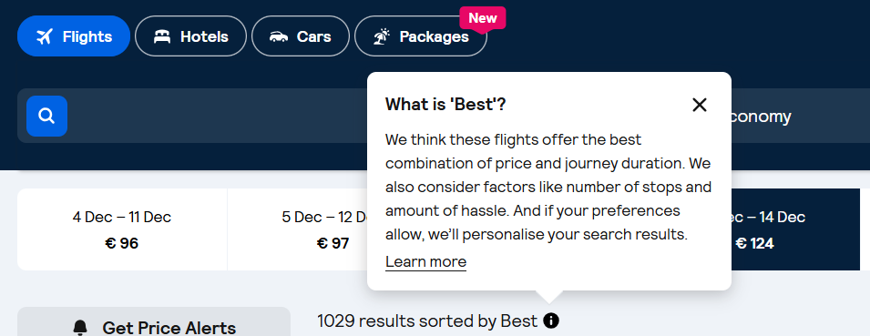

Generally, when the English copy says “best”, it’s safe to translate it the same way. When this is not the case, do not use “best” or other superlatives. Instead, use subjective claims such as “epic prices” or “amazing deals”.

The use of “Discount”

Skyscanner never offer discounts to users. Any discounts come from partners (for example Trip.com), not from Skyscanner.
For this and especially for legal reasons we can therefore never imply that “we offer” or “Skyscanner offers” a discount. This must be translated in a neutral way, i.e. “You are offered a discount”.

Never use the translation or equivalent of “discount” when the English source refers to a “deal” or “price drops” – these are not discounts but results of price fluctuation and it would be legally incorrect to refer to discounts.

Do | Don’t
Vores tilbudsfunktion viser dine flyrejser, der er faldet med mindst 20 %. | Vores tilbudsfunktion viser dine flyrejser med en rabat på mindst 20 %.

Translating sustainability-related content
When localising content about anything related to sustainability for Skyscanner, it’s essential to communicate responsibly and avoid greenwashing. Travel has an undeniable environmental impact, and our language must reflect this honestly and transparently. Use the following principles when translating or adapting sustainability-related content:
- Prefer comparatives over absolutes. Use relative statements such as “X er mere bæredygtigt end Y”, rather than implying that any option is fully sustainable.
- Avoid superlatives. Do not use expressions like “den mest miljøvenlige flyrejse” or “det grønneste valg”, as they can overstate environmental benefits.
- Use transparent and factual language. Base all claims on clear, measurable data.
- Steer clear of vague or unregulated terms. Avoid words like ‘naturlig’, ‘grøn’, ‘giftfri’, and ‘miljøvenligt’, unless the statement is supported by verifiable, standardised criteria.
- Do not make unsubstantiated claims. Only reference environmental performance when data is available. Never imply that a flight or travel option is “bæredygtigt,” “øko,” “grøn,” “ren,” “godt for planeten,” or “skyldfri.”
- Avoid reinforcing “green” imagery or symbolism. Be cautious with metaphors and word associations that might imply aviation is environmentally harmless. Overuse of green or nature-themed language can unintentionally suggest a level of sustainability that does not exist in commercial aviation today.

Do | Don’t
Denne rejse udleder 20 % mindre CO₂ end et typisk fly på denne rute | Denne rejse er 20 % mere miljøvenlig/lav-emission end et typisk fly på denne rute
 | Dette er en bæredygtig flyrejse
 | Dette er det mest bæredygtige fly
 | Dette er et grønnere valg

Accessibility guidelines

See the localised Accessibility guidelines here

Useful resources and links

sproget.dk
dsn.dk
ordnet.dk

